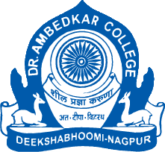
Parampoojya Dr. Babasaheb Smarak Samiti’s
Dr. Ambedkar College, Deekshabhoomi, Nagpur
Webinar on
Vulnerability and the Constitution
Organized by
DEPARTMENT OF LAW
25th January ,2023
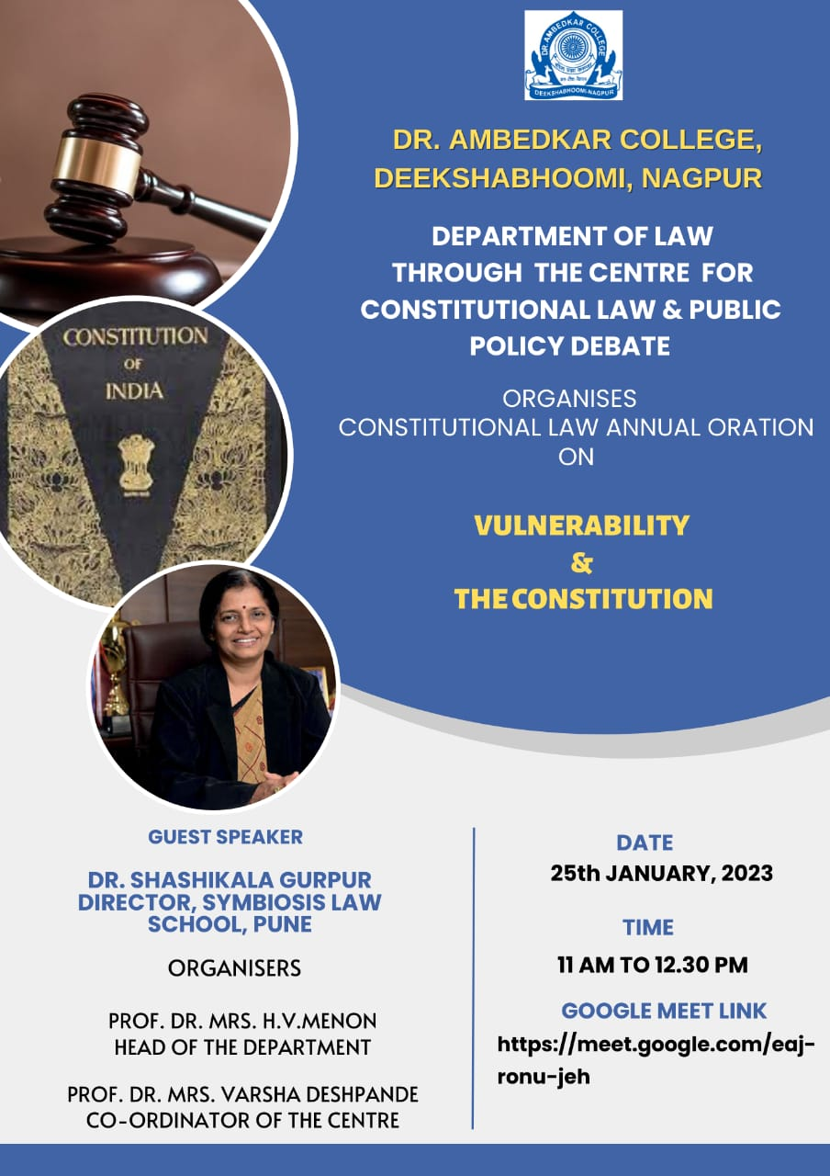

Report:
Dr. Ambedkar College, Department of Law, Deekshabhoomi, Nagpur, through its Centre for Constitutional Law and Public Policy Debate had organized Constitutional Law Annual Oration on ‘Vulnerability and the Constitution’ for its LL.B. and LL.M. students on 25/1/2023 from 11 am to 12:30 pm through online mode. The resource person for the Webinar was Dr. Shashikala Gurpur, Director, Symbiosis Law School, Pune. The session was conducted by Ms. Shazia Bari, Assistant Professor, Department of Law, Dr. Ambedkar College, Deekshabhoomi, Nagpur.
The welcome address was delivered by the Head of the Department, Dr H.V. Menon wherein she highlighted the various provisions of inclusion provided in the constitution and discussed the importance of understanding this concept.
The speaker introduced the concept by discussing as how the vulnerable’s in the society have been ignored from time immemorial. She highlighted various areas such as health care, legal services wherein there is lack of focus on the vulnerable’s.
The speaker then discussed about various theories of vulnerability given by thinkers such as Marta Fineman etc. She also discussed the ideas of vulnerability given by thinkers like Marry Hilly. She then highlighted the dynamic nature of the Constitution of India and discussed the important role played by the Lawyers and Judges in upholding the dynamic nature of the Constitution. She also discussed various provisions of the Constitution which protects vulnerability to give a better understanding to the participants.
The lecture was then followed by Question – Answer Session. Vote of thanks was proposed by Ms. Aishwarya Peshwe, Assistant Professor, Department of Law, Dr. Ambedkar College, Deekshabhoomi, Nagpur. The program was undertaken under the guidance of Dr.Mrs.Varsha Deshpande, Co-ordinator of the Centre for Constitutional Law and Public Policy Debate. The Session was attended by approximately 95 participants of the LL.B. and LL.M. Course of the Department of Law. The feedback was also taken from the students.

